Bahria University,

Karachi Campus



LAB EXPERIMENT NO.

**1**

LIST OF TASKS

|  |  |
| --- | --- |
| TASK NO | OBJECTIVE |
| **1** | **Write a Python program to calculate the roots of a quadratic equation of the form ax2 + bx + c = 0, where a, b, and c are coefficients provided by the user.** |
| **2** | **Write a Python program that calculates the factorial of a non-negative integer n provided by the user.** |
| **3** | **Write a python program to find the maximum and minimum number in the following array {12,56,34,2,56,98,6,54,6,54}** |
| **4** | **Write a Python program that checks whether a given positive integer n provided by the user is a prime number or not.** |
| 5 | Write a python program that takes two matrix (2 by 2) from user, and perform addition, subtraction, multiplication and division on them. |

Submitted On:

**Date: ___________**

**Task No. 01:**

**Write a Python program to calculate the roots of a quadratic equation of the form ax2 + bx + c = 0, where a, b, and c are coefficients provided by the user.**

**Solution:**

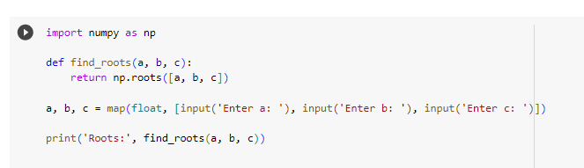

**Output:**

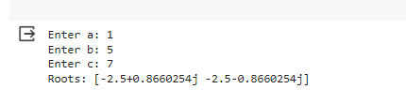

**Task No. 02:**

**Write a Python program that calculates the factorial of a non-negative integer n provided by the user.**

**Solution:**

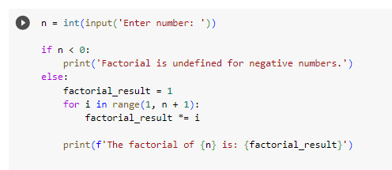

**Output:**



**Task No. 03:**

**Write a python program to find the maximum and minimum number in the following array {12,56,34,2,56,98,6,54,6,54}**

**Solution:**

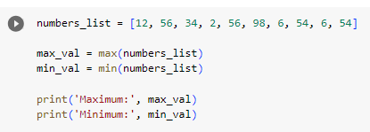

**Output:**



**Task No. 04:**

**Write a Python program that checks whether a given positive integer n provided by the user is a prime number or not.**

**Solution:**

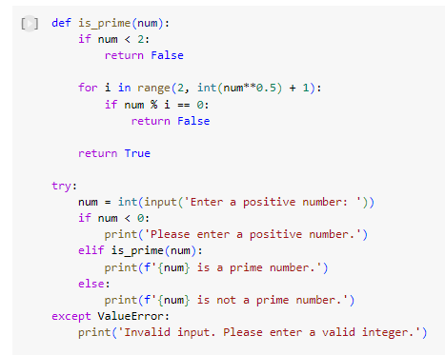

**Output:**

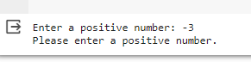



**Task No. 05:**

**Write a python program that takes two matrix (2 by 2) from user, and perform addition, subtraction, multiplication and division on them.**

**Solution:**

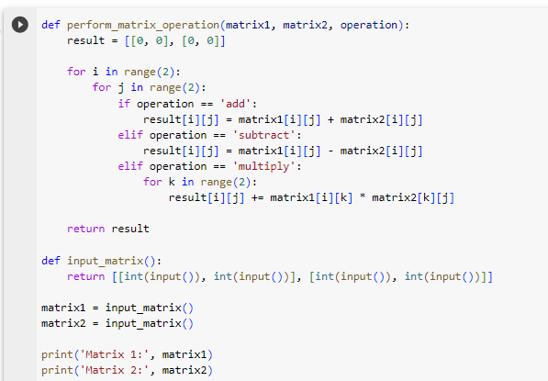

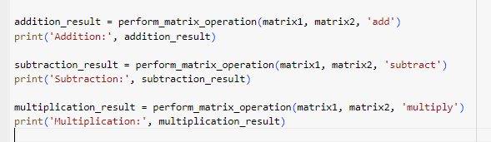

**Output:**

